**Query Reports Portal Documentation**

**Introduction**

Query Report Portal is a web-based application that allows users to generate Query Report from a SQL Query saved in the portal. This documentation aims to provide information on how to use only the admin panel of the said portal and its features.

**Getting Started**

To get started with Query Report Portal Admin Panel, follow these steps:

1. Open your web browser and go to on
   * <http://172.20.100.81:8001/admin/>

* <http://172.20.100.81:8002/admin/>
  + <http://172.20.200.40:8001/admin/>

1. Login using your id and password.

**Users**

Users can be created using this link:

* <http://172.20.100.81:8001/signupuser/>

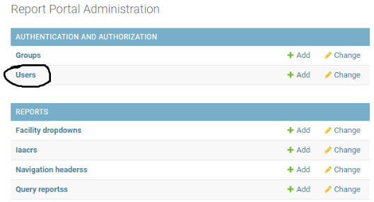**Accessing Admin Panel: Elevating User Permissions**

By default, regular users do not have the authorization to view reports or access the admin panel. To access the admin panel, a user must be granted admin rights by an existing admin user. This documentation aims to provide information on how to elevate a user's permissions to access the admin panel.

Step 1: Search User

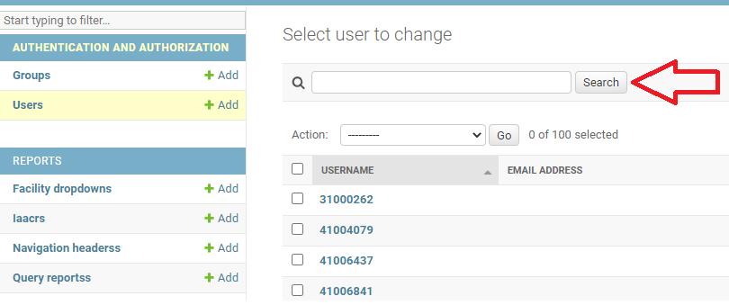To grant a user admin rights, navigate to the "Users" section in the admin panel. Using either the user's Username or First Name, search for the user in question.

Step 2: Select User

After performing the search, select the user by clicking on their Username.

Step 3: Edit User Permissions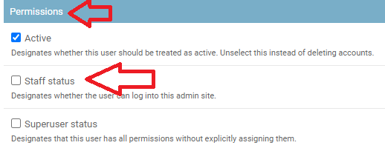

Once you've selected the user, navigate to the "Permissions" heading. Click on the checkbox labeled "Staff Status" to grant the user admin rights.

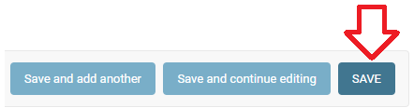Step 4: Save Changes

After selecting the "Staff Status" checkbox, click on the "Save" button to apply the changes.

**Accessing Admin Panel: Granting User Access to View Reports**

Accessing the admin panel grants users the ability to view reports. To provide access to reports, follow these steps:

Step 1: Log in the Admin Panel

To provide access to reports, follow steps 1 and 2 in the "Elevating User Permissions" documentation. This will take you the users profile.

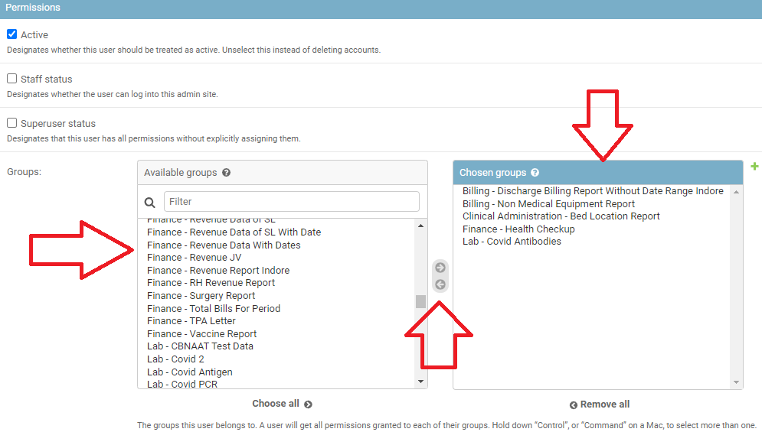Step 2: Manage Report Access

Navigate to the "Groups" section in the admin panel. Under the "Groups" heading, there are two text boxes: the left box indicates all available reports, and the right box indicates which reports are available to the user.

Step 3: Grant Report Access

To provide access to a report, search for the report in the left box and click on the right arrow. This will add the report to the right box and make it available to the user.

Step 4: Remove Report Access

If you need to remove a report's access from the user, select the report in the right box and click on the left arrow. This will remove the report from the user's available reports.

**Adding a New Report to the Query Reports Portal**

To add a new report to the query reports portal, follow these steps:

Step 1: Create a Group for the Report

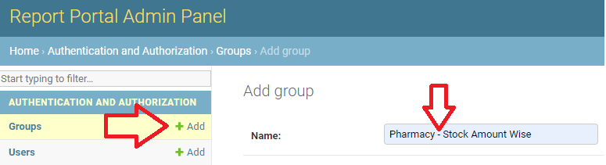

First, log in to the admin panel and create a group for the report. A group acts as a relationship between users and reports. Click on the "Add" button and enter the name of the report. Please ensure you follow the correct format, which includes entering the heading where the report is supposed to be displayed, followed by a hyphen "-", and then the name of the report. Please note that this is the only time you should use a hyphen. Using special characters in the report's name may result in unpredictable behaviour of the application. Once you have input a valid name, click on "Save".

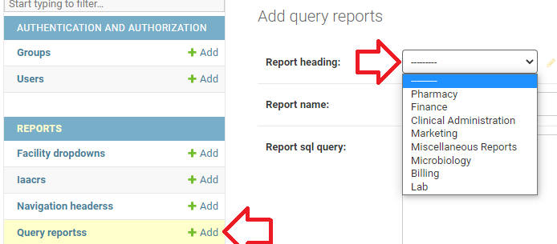Step 2: Add Report to Query Reports

Next, click on the "Query Reports" add button under the "REPORTS" heading. Select a report heading from the dropdown menu. This will determine under what heading the report should be displayed to the user in the navigation bar.

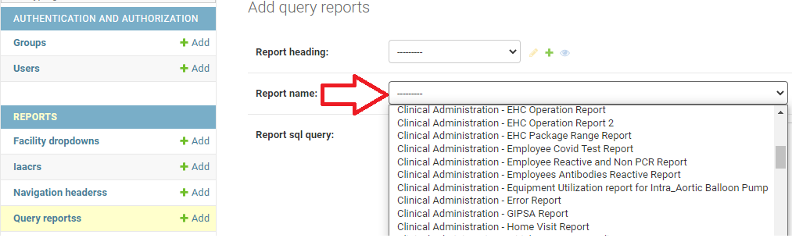

Then, select the report name from the dropdown menu. Here, you will see all the options that you added in the groups section.

Step 3: Enter SQL Query

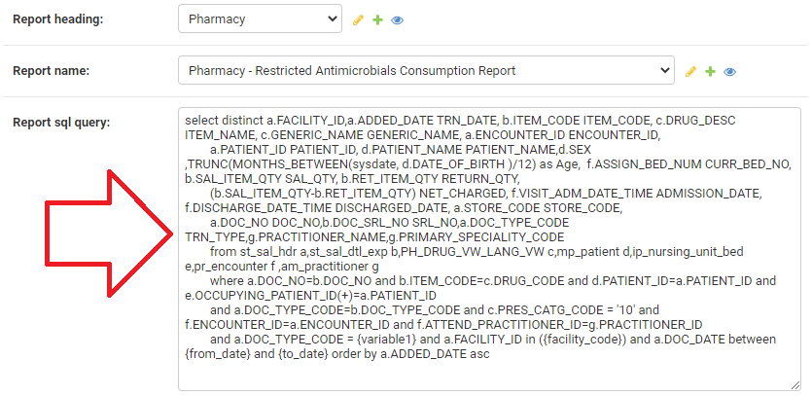

Finally, enter the SQL query in the "Report SQL Query" text box.

**Variables in the SQL Query:**

**Creating a Dropdown from Another Query/Subquery**

To create a dropdown from a subquery that retrieves data from the database and displays it, follow the steps below:

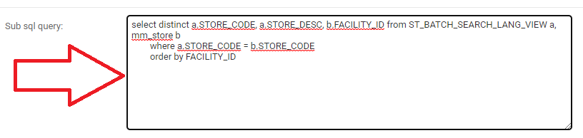

1. In the "Sub SQL Query" textarea, copy and paste your subquery.

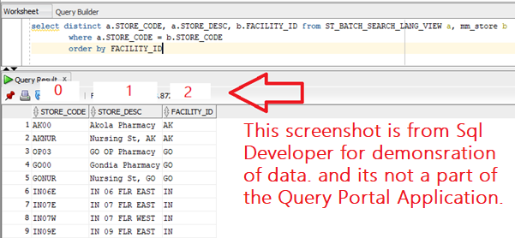

1. Use the "Dropdown Option Value" option to determine what value should be replaced in the main query. This is a numeric input box where you can input the column number indexing from zero.

1. Use "Dropdown Option Name1" and "Dropdown Option Name2" to determine what data should be displayed to the user. These options are for user-friendliness and will have no impact on the query. As shown in the screenshot selecting 2 and 1 in dropdown option names resulted in column 3 being displayed first followed by a hyphen (-) and then column 2.
2. 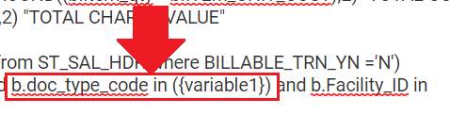Modify the SQL query to create a substitution in the query variable. Wrap the variable1 in curly braces like this {variable1} in the query as shown in the screenshot. Please note, it is compulsory to use the word variable1.
3. Avoid adding single quotation marks **' '** as the software does this automatically for you.

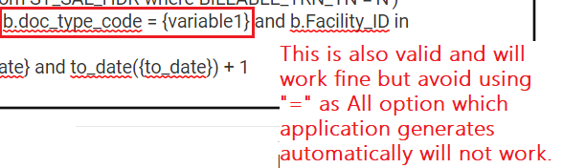

1. When using a subquery, the software will automatically create an "ALL" option at the bottom of the dropdown. Therefore, use the "IN" expression instead of "equals" expression as shown in the expression: "column_name_to_be_substituted in ({variable1})."

**Adding a Facility Dropdown to the report.**

To add a Facility Template to the report, enable the checkbox labelled "Facility Template" in the admin panel. This will create a dropdown with all facilities to select from. To create a variable/substitution in the SQL query, use the word "facility_code" enclosed in curly braces like this: {facility_code}. Please do not add any quotation marks as the application will add them automatically.



If you want the query to work with the "All" option, use the "in" expression instead of the "equal to" ( = ) expression.

**Pharmacy Drug Dropdown**

1. The query reports portal includes a pre-made dropdown for Pharmacy Drugs. To use this dropdown, you must select the checkbox labelled "Pharmacy IAARC Dropdown."

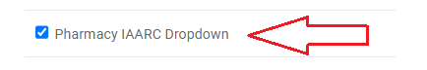

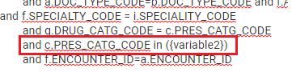

1. To substitute this dropdown in the SQL query, you must use the word "variable2" wrapped in curly braces. For example, use the expression "column in ({variable2})" as shown in the screenshot.

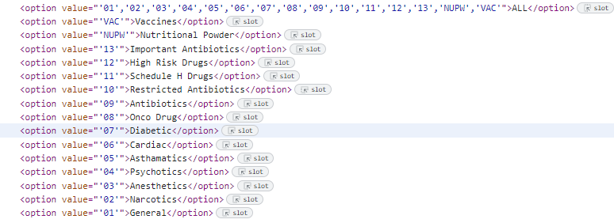

1. Please note that this pre-made dropdown is available exclusively for Pharmacy Drugs, and attempting to use it for other purposes may result in unpredictable behaviour. Additionally, ensure that you **do not add** single quotation marks (' ') around the curly braces, as the application will add them automatically. In the above screenshot you can see what values will be substituted again their named selection.

By following these instructions, you can take advantage of the pre-made dropdown for Pharmacy Drugs in the query reports portal.

**Date Template**

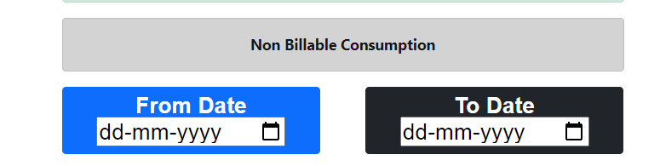

1. 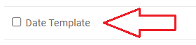To add a date template in a report, you need to check the Date Template option on the admin panel. This will enable a date range selection field in the report generation page for the user to select the desired date range.
2. To substitute the selected date range in the SQL query, you need to use the placeholders {from_date} and {to_date} wrapped in curly braces. For example, if you want to filter records between the selected date range for a particular column, you can use the following syntax in your SQL query: column_name between {from_date} and ({to_date})



**Instructions for Adding Time Template to Reports:**

1. To add a time template to a report, first check the "Time Template" option in the admin panel. Note that the time template must be used together with the date template, and there is no need to modify the SQL query. The application will automatically attach the time to the date.
2. It is important to define the time correctly in the query and us this format 'dd-mon-yyyy hh24:mi:ss'. For example, if you want to use the "DISPENSED_DATE_TIME" field, you should define it as follows:

DISPENSED_DATE_TIME BETWEEN to_date({from_date},'dd-mon-yyyy hh24:mi:ss') AND to_date({to_date},'dd-mon-yyyy hh24:mi:ss')

**Custom Dropdown**

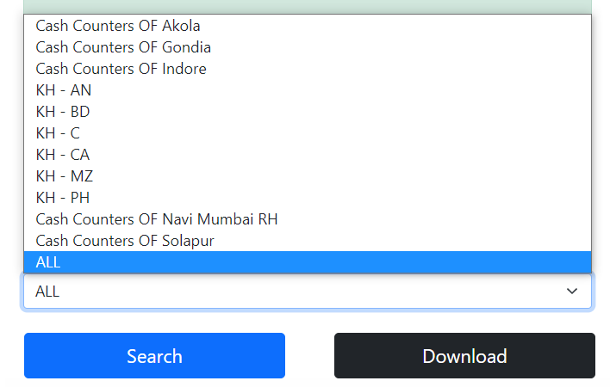

To create a custom dropdown for users with custom values and options, follow these steps:

1. Go to the Custom Dropdown Options value section in the admin panel.

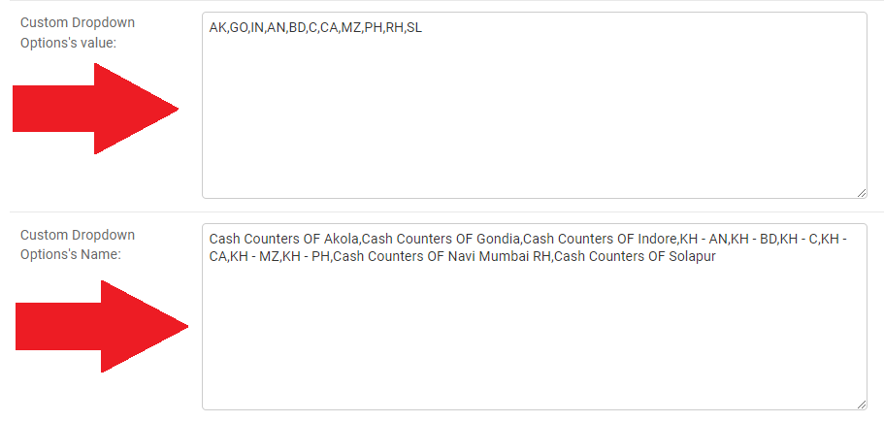

1. Enter the values that will be substituted in the SQL Query in the Value textbox, separating each item with a comma.
2. Define a name for each option using the Custom Dropdown Option's Name textbox, separating each item with a comma.
3. Ensure that the values and names are in the same sequence.
4. Note that the application will automatically create an "All" option.
5. To ensure that the substitution of values works properly, it is important to define whether to include single quotation marks ( ' ' ) around the substituted value in either the Custom Options Value field or in the SQL query. The **application does not automatically add quotation marks**, so they need to be added manually. This means that you should make sure that single quotation marks are present in one of these two.

**OR  
**

1. To substitute the value in the SQL Query, use the word "variable3" with curly braces wrapped in single quotation marks (''), as shown in the example.

Example: Suppose you want to create a custom dropdown for a list of states in a country, with the values being the state codes and the names being the state names. You would enter the state codes in the Value textbox and the state names in the Custom Dropdown Option's Name textbox, both separated by commas. The SQL Query would then contain a variable3 wrapped in single quotation marks ('') that would be replaced by the selected state code:

SELECT * FROM table WHERE state_code = '{variable3}'

**Custom Input Box OR Text Box**

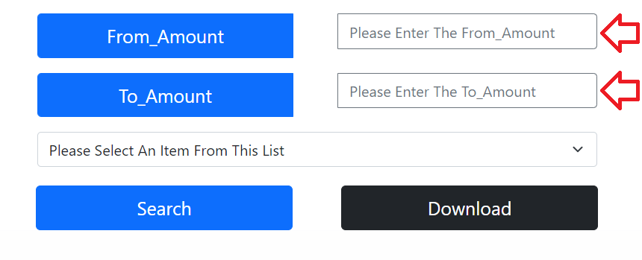

1. 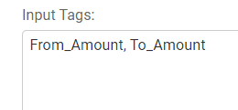To create a custom input box, use the "input tags" option. You can create multiple input boxes by separating each using a comma (","). Ensure that you do not use spaces in the names of the input tags but use underscores instead. Using spaces might result in unpredictable behaviour of the application.



1. Furthermore, to substitute the value in the SQL Query, use the exact same name wrapped in curly braces. For example, if you have created an input tag named "UH_iD", then use "{UH_iD}" in the SQL. Please note that you should not use any quotation marks, as the application will automatically add them.
2. 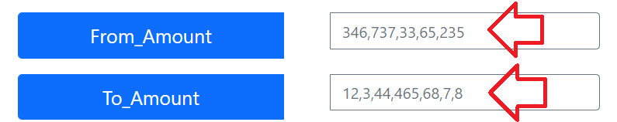Users can enter multiple values separated by comma (,)

**Display Data in the Web**

1. To display data in the web browser instead of downloading it in the Excel format, you can use the "Display Within Browser (No Download Option)" checkbox. By selecting this option, the data will be displayed directly within the browser. This can be useful if you want to quickly view the data without having to download and open an Excel file.
2. Please note that this option may not be suitable for large amounts of data or data that requires further analysis. In such cases, it may be more appropriate to download the data and work with it in Excel.

**Editing and finding a report to Edit.**

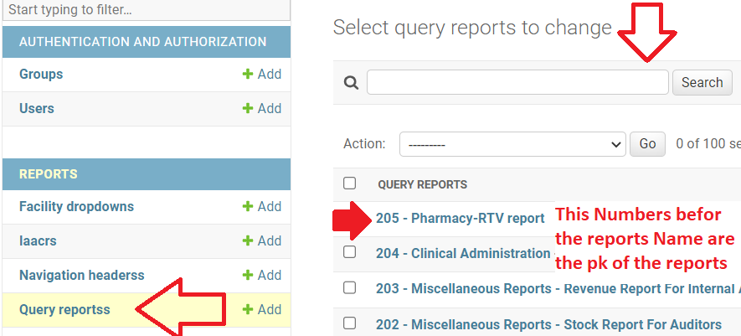

To edit or view a report in the query report, follow these steps:

1. Click on "Query reports" in the admin panel.
2. Locate the search input box and enter either the name or pk of the report you want to edit or view.



1. To find the pk of a report, you can check the URL of the report when you view it. The pk is the number after "/one_for_all/" in the URL.
2. Once you have found the report, click on its name to view or edit it.